1 | Find the area ( probability ) to the left of a z score of 2.18  Round to 4 decimal places or a % to 2 decimal places

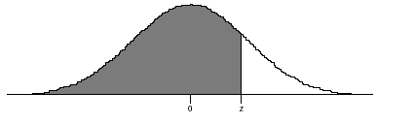
0 2.18

2 | Find the area ( probability ) to the right of a z score of -1.99  Round to 4 decimal places or a % to 2 decimal places - figure not drawn to scale

-1.99 0

3 | Find the area ( probability ) in a right tail where the z score is 2.19  Round to 4 decimal places or a % to 2 decimal places - draw your own figure if necessary

4. | Find the area of the shaded region between the z scores  Round to 4 decimal places

Z scores -2.03 1.49

5. | If the area of the shaded region is 39.05% or .3905, find the z score at the question mark.  Round to 2 decimal places

Figure for # 5

Z SCORES ? 0

6 | Find the z score if the NON-shaded region indicated by the arrow is .0993  Round to 4 decimal places

Figure for # 6

7 | Round to 4 decimal places or a 2 place decimal

When a bell curve is shaded from a
z score of ZERO (0) all the way to positive infinity, what is the area (probability) covered?

8. | Find the z score if the area of the shaded region is .7002  Round to 2 decimal places

Figure for # 8

Z score

9. | Find the z score if the area of the shaded region is .0290  Round to 2 decimal places
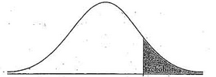

10. | 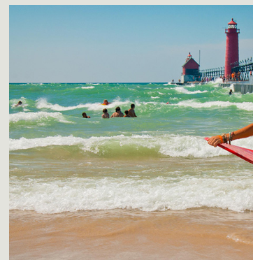The average age of a visitor to Grand Haven State Park in Michigan was found to be 32.65 years. The stdev was found to be 5.26 years depending upon the weather and other factors. Find the probability that a person selected at random will be greater than 29 years of age.  Round to 2 decimal places.

11. | The photo to the left is of a dust mask. These masks are evaluated based on the number of particles of dust and pollen that can pass through the filter. If a mask does not meet minimum standards, it is rejected. A mask must not allow more than 4.3 % of all particles to pass through it. It has been found that the average number of particles passing through these masks is 240,000. The stdev is 100,000 particles depending upon size and the age of the mask. Find the lower cutoff score ( number of particles) that will qualify (or disqualify) a mask. Answer to 2 decimal places  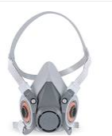  filter

12. | 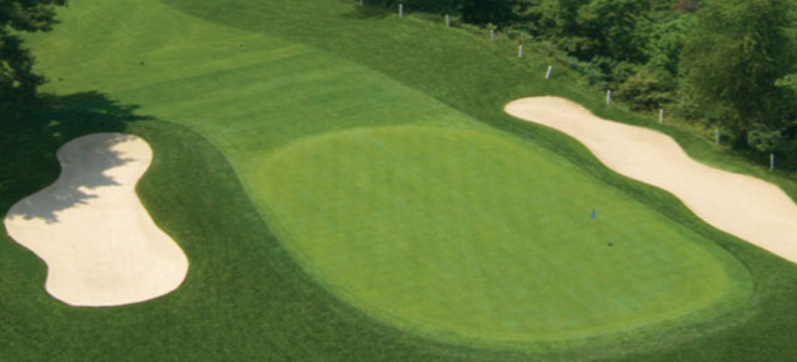Cedarsville Golf Course owns and operates three riding mowers that are able to mow greens. ( for you non-golfers, greens are the smooth areas where putting takes place). The golf course greens keeper estimates that the average time it takes to mow a greens is 6.78 minutes with a stdev of 1.09 minutes. Cutting time depends on the length of the grass, the moisture level and the pace of the person mowing. Find the probability that a green will be mowed between 6 minutes and 8 minutes. 2 decimal places

13 | Facts and falsehoods regarding the standard normal bell curve: which ones are true ?  - The bell curve has an area under it = 1.00  - The bell curve is symmetric  - The bell curve is discrete in nature  - The bell curve is not infinite  - The bell curve has its mean, median and mode in the same place
14. | True/false  Z scores are the same as real scores
15. | TRUE FALSE  A bell curve is also known as a Gaussian Distribution

Bonus problem 1
Note: this problem requires reading the book material and a special formula:

Average hourly rates for the 2 Broke Girls waitresses were $9.95 as of May 2012, according to the U.S Bureau of Labor Statistics -- or $20,710 per year. This equates to $1,725.83 per month. The average per month includes tips of $ 66 per day with a stdev of $ 18 per day dependent upon weather, days worked etc. If a sample of 49 days are analyzed, what is the probability that the mean amount FOR TIPS for the 2 Broke Girls will be greater than $ 60.36 ?

Round to 2 decimal places

Bonus Problem 2

The Smicksburg Connolly Heritage Foundation found that 8.0235% of its employees are currently enrolled in one or more college classes. If the company has 16000 employees, find the probability that less than 40 employees are enrolled in one or more college class.
NOTICE---THIS IS NOT SIMPLY 16000 TIMES 8.0235%!!!

